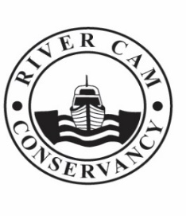
CONSERVATORS OF THE RIVER CAM
Navigation authority for the River Cam, between Cambridge and Bottisham Lock

Change of Ownership Form

If you sell, or otherwise dispose of, your boat it is your responsibility to inform us of the change of ownership. Please complete and return this form within 14 days of transfer of ownership to the address shown at the foot of this page.

1. Craft Registration Number
2. Craft Name (if applicable)
3. Date of Change of Ownership

4. Full Name and Address of Seller
5. Post Code
6. Telephone Number of Seller
7. Email

Signature of Seller : _______________________________________

7. Full Name and Address of Buyer
8. Post Code
9. Telephone Number of Buyer
10. Email

Signature of Buyer : ______________________________________

