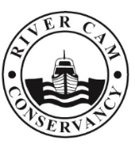
CONSERVATORS OF THE RIVER CAM
Navigation authority for the River Cam, between Cambridge and Bottisham Lock
Conservator of the River Cam
Observer nomination form
Position Overview:
The role of the Conservator of the River Cam Observer is a non-statutory, non-voting position aimed at fostering collaboration between various river user groups and the Conservancy. Observers play a crucial role in communicating information and facilitating engagement between the Conservancy and their respective groups.

Name
Contact details including email address
Your interest in the river
Skills relevant to the appointment
Why you wish to be appointed as an Observer
Please use an additional sheet if required.
Signature
Date
Please return completed form to the Clerk clerk@camconservators.org.uk

